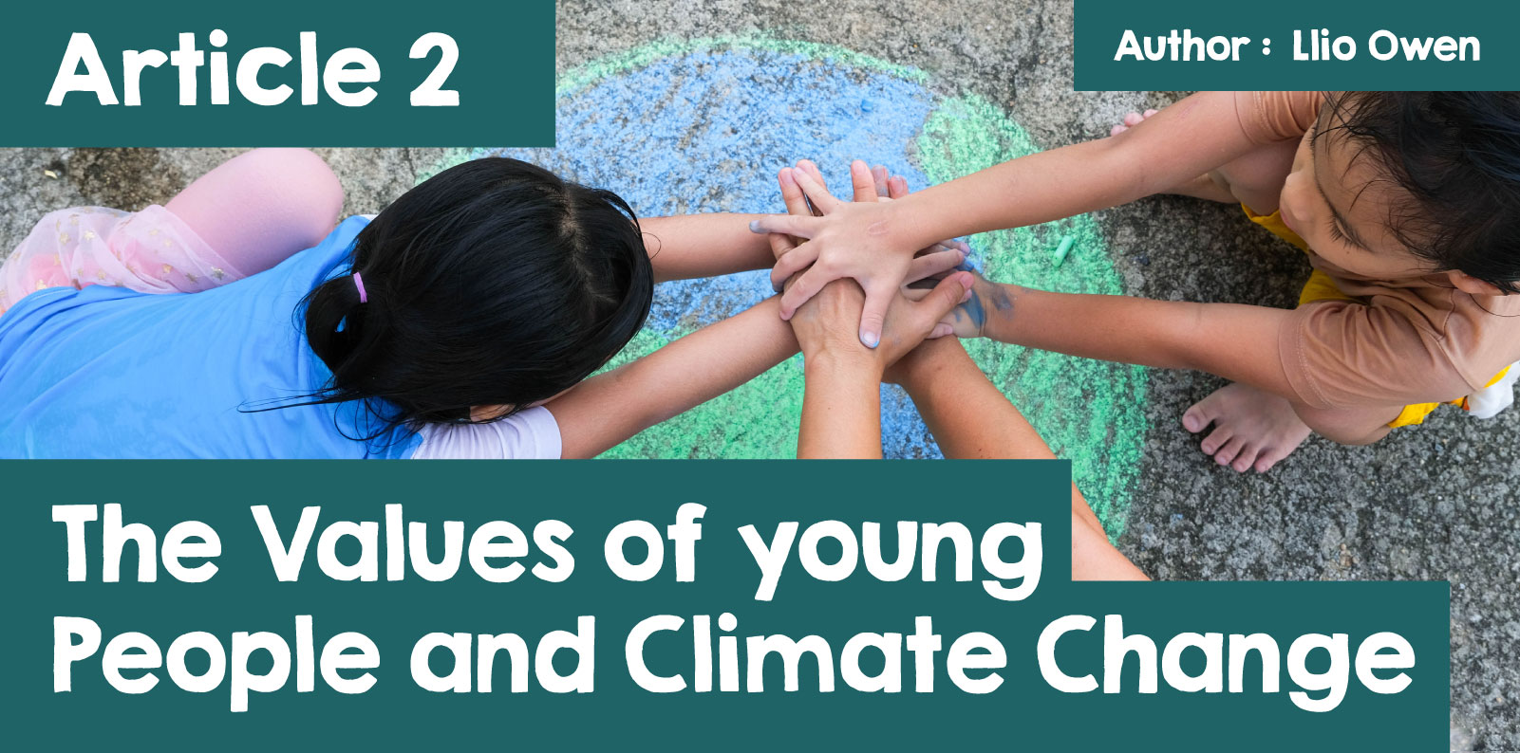

The Values of young People and Climate Change

Climate change, deforestation, pollution, and the loss of biodiversity are some of the biggest challenges facing the world today, and through the media we see young people are stepping up to address these issues, leading the charge for change and passionately advocating for the protection of the planet. Their concern for the environment reflects their deep sense of responsibility to take care of the Earth, driven by values of fairness, justice, and sustainability.

Many young people today care deeply about the environment and are often at the forefront of movements pushing for action on climate change. Many participate in climate strikes, support renewable energy, and demand policies that protect the health of the planet. But this activism goes beyond just politics—it’s also rooted in a strong moral and ethical sense. For young people, environmental protection is seen as a matter of justice. They view the damage being done to the Earth as a serious problem, especially when it impacts vulnerable communities and future generations e.g. floods or storms damaging vital infrastructure and destroying belongings at home. This belief in fairness and the need to protect those most affected by climate change inspires much of their activism.

One of the key ideas driving young people’s environmental values is the idea of "stewardship"—the belief that humans have a responsibility to take care of the Earth and its resources. This belief is shared across cultures, religions and communities, and it speaks to the need for everyone to work together to protect the planet. Many young people see themselves as stewards of the Earth such as Poppy Stowell-Evans a former chair of The Youth Climate Ambassadors for Wales (YCA). YCA is a group of 12 young people from across Wales who are passionate Climate Activists fighting for Climate Justice.

|  |
| --- |
| Llun yn cynnwys dillad, person, dan do, esgidiau  Wedi cynhyrchu’r disgrifiad yn awtomatig  *Picture of YCA members at the Changemakers Conference 2024 in Cardiff* |

Poppy believes it’s our duty to make sure that future generations can enjoy a healthy planet.

|  |
| --- |
| Llun yn cynnwys person, wyneb dynol, dillad, awyr agored  Wedi cynhyrchu’r disgrifiad yn awtomatig  *Poppy Stowell-Evans* *(Picture from BBC News -*[*COP26: Sense of hope needed on climate change - Drakeford - BBC News)*](https://www.bbc.co.uk/news/uk-wales-59112288) |

“Often, as a young climate activist, I’m asked about how climate anxiety has impacted me. I usually discuss how fear of inaction has caused me many sleepless nights, from nightmares to the overwhelming feeling of powerlessness. However, a solution I have promoted and will continue to promote to combat climate anxiety is to take action yourself and, most importantly, to understand why you want to take this action.” [(Poppy Stowell-Evans, 2022)](https://sizeofwales.org.uk/news/blog-climate-activism-against-eco-anxiety/)

Watch the video below - Poppy Stowell-Evans discusses climate anxiety

[Climate anxiety & action | Poppy Stowell-Evans - YouTube](https://www.youtube.com/watch?v=ZEykCLQavgg&source_ve_path=OTY3MTQ)

This sense of responsibility encourages many young people to take action, whether it’s by reducing their own carbon footprint, raising awareness, or advocating for large-scale policy changes.

When asked “What does Stewardship mean to you?” Cadi Midwood of Ysgol Botwnnog answered, “For me, it means to look after the world and maintain it for the future generations so they can continue to enjoy what we have today”. It shows that young people like Cadi have a collective approach to climate change, which is vital to be able to tackle the issue.

For many young people, environmental activism is closely linked to their personal values. They see protecting the planet not only as a practical necessity but also as an expression of their beliefs about fairness, justice, and respect for all living things. For example, young activists often emphasize the importance of sustainability—making sure that we use natural resources in a way that doesn’t deplete them for future generations. They also highlight the need to address inequality, as climate change often disproportionately affects poorer communities and countries that are least responsible for causing it. This concern for fairness motivates many young people to push for climate policies that not only protect the environment but also help those most affected by its degradation.

One of YCA’s latest campaign to push for climate policies is raising awareness of Climate Refugees. YCA Wales feels strongly about putting legislation in place to protect Climate Refugees of the future. Climate Refugees are people who have been forcibly displaced due to climate change, losing their homes, their safety, and their means of living. YCA is aiming to receive 10,000 signatures from the UK public and receive a response from Parliament on this issue.

In a blog, Poppy (former chair of YCA) reflects on her reasons for joining YCA - “I wanted to create the change I needed to see, not just for myself, but for those across the world who have been ignored- the vulnerable in society left to fend for themselves as they face the consequences of our reckless and greedy actions” [(Poppy Stowell-Evans, 2021)](https://welshgovernment.blog.gov.wales/2021/11/25/meet-the-young-welsh-voice-leading-wales-climate-talks/)

The actions young people are taking to protect the planet are a powerful example of their commitment to environmental values. Whether it’s participating in protests, working to reduce waste, or supporting the shift to renewable energy, young people are finding ways to make a difference.

|  |
| --- |
| Llun yn cynnwys dillad, person, esgidiau, gwên  Wedi cynhyrchu’r disgrifiad yn awtomatig  *Photo of Poppy at the UN Climate Change Conference UK in 2021* [*Poppy Stowell-Evans, 2021.*](https://welshgovernment.blog.gov.wales/2021/11/25/meet-the-young-welsh-voice-leading-wales-climate-talks/) |

As previously mentioned in Article 1, the most notable today is Greta Thunberg – In August 2018, aged 15, Thunberg began skipping school, vowing to remain out of school until after a Swedish election to attempt to influence the outcome. She protested outside the Swedish parliament where she called for stronger action on climate change by holding up a *Skolstrejk för Klimatet* (School Strike for Climate) sign and handing out informational flyers. This led to world fame and made her an ad hoc leader in the climate activist community. She faced heavy criticism, much of it mocking her as a naïve teenager, but Thunberg's influence on the world stage has been described by *several media outlets as the “Greta Effect”*. She has received honours and awards, including in *Time's* 100 most influential people, named the youngest *Time* Person of the Year in 2019, inclusion in the Forbes list of The World's 100 Most Powerful Women (2019), and nominations for the Nobel Peace Prize.

Watch the video below of Greta Thunberg’s interview on ‘how to tackle climate anxiety’

[Greta Thunberg on how to tackle climate anxiety | The One Show - BBC - YouTube](https://www.youtube.com/watch?v=pK_nBKtWyvk&source_ve_path=OTY3MTQ)

Like Thunberg, many young people are also embracing sustainable lifestyles—reducing consumption, avoiding single-use plastics, and choosing eco-friendly products. By making these choices, they are showing that individual actions can add up to make a big impact. Katie and Kacey from Ysgol Botwnnog said that they contribute to a sustainable way of life by being conscious of their consumption. Over-consumption of clothing means tonnes of waste is send to landfill, so using apps like Vinted or Depop contributes to the circular economy and saves you money at the same time! However, they also understand that big changes are needed, which is why they advocate for government and corporate policies that address climate change on a larger scale.

The values of young people today are a powerful force for change. Their commitment to fairness, justice, and sustainability is driving a global movement to protect the planet. By standing up for the environment, young people are showing that they care not only about their own future but also about the well-being of future generations and the most vulnerable communities. As more young people take action, they are leading the way toward a healthier, more sustainable world.

“The climate crisis is in our hands because ultimately your voice is just as important and needed as who we consider to have the ‘power’ – please don’t be afraid to use it!” [(Poppy Stowell-Evans, 2021)](https://welshgovernment.blog.gov.wales/2021/11/25/meet-the-young-welsh-voice-leading-wales-climate-talks/)