



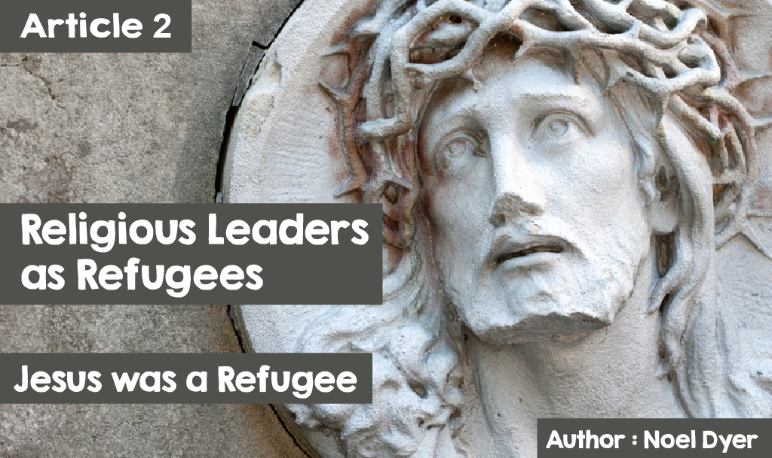

In September 2015 images of a Syrian refugee body washed up on a seaside in Turkey shocked the world. Aylan Kurdi was three years old and lay dead on the beach. He was one of tens of thousands of refugees but the pictures of him crystallised the suffering of the rest.

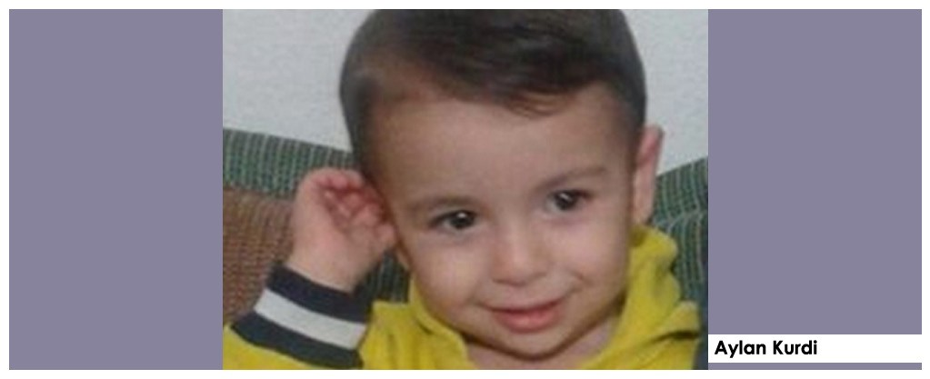

Today, people's attitude towards refugees from Syria and elsewhere in the Middle East is mixed and complex. There's a lot of sympathy, definitely. Partly perhaps because the history of the refugees has much in common with the life of Jesus.

Jesus, Mary and Joseph were refugees in the Middle East. The story of the birth depicts a family looking for a place to stay only to discover they had no place in Bethlehem.

***‘While they were there, the time came for the baby to be born, and she gave birth to her firstborn, a son. She wrapped him in cloths and placed him in a manger, because there was no guest room available for them.*** (Luke 2:6-7).

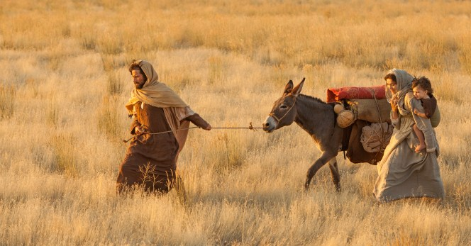

Shortly after his birth, the family had to flee King Herod's cruelty. He threatened to kill all boys under the age of two in the Bethlehem area. Mary and Joseph and the baby Jesus managed to reach refuge in Egypt where the family remained until it was safe for them to return to the land of Israel and the town of Nazareth.

***‘When they had gone, an angel of the Lord appeared to Joseph in a dream. “Get up,” he said, “take the child and his mother and escape to Egypt. Stay there until I tell you, for Herod is going to search for the child to kill him.” So, he got up, took the child and his mother during the night and left for Egypt,”***

(Mathew 2:13-14).

**Muhammad was a refugee.**

It is arguable that there is also much in common between the plight of refugees today and the story of the prophet Muhammad. Muhammad and his supporters were refugees. The message of Muhammad and his followers of about a hundred men and women had been rejected by the majority of the people of Makkah city. According to history, they had to leave the city as they were being abused and threatened.

Fortunately for the prophet, they were welcomed by the people of Madinah and the small group of Muslims were invited to live there safely. The people of the city wanted to know about the new religion, Islam, and Muhammad taught them about Allah and his message. Muhammad became leader of the city of Madinah and founded the first Islamic state there.

This event is of major importance to Muslims. The name Hijrah was given to the refugee journey from Makkah to Madinah (both in Saudi Arabia) in the year 622 CE (Common Era). The event of welcoming the refugees is so significant that 622 CE became the year of the beginning of the calendar in Islam – indeed, the official year of the beginning of the religion.

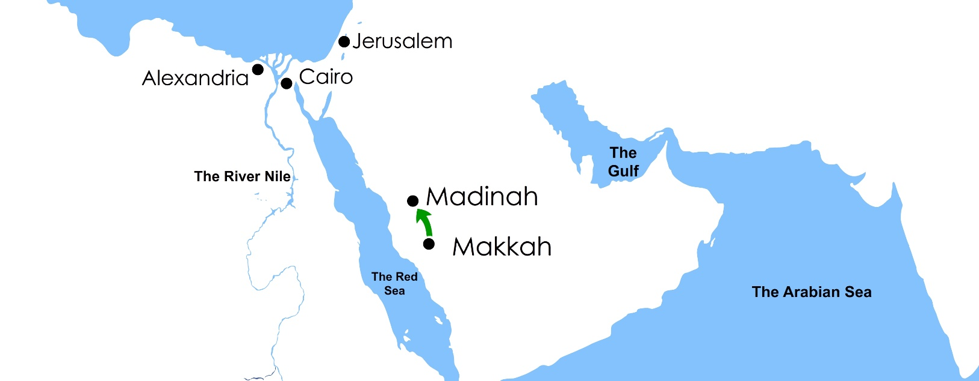

**The Dalai Lama is a refugee.**

The Dalai Lama is the spiritual leader of Tibetan Buddhists - he is number 14 in a series of Tibetan Buddhist leaders. Tibet is not prominent on world maps as the country has been occupied by mainland China since the 1950s. He was born in 1935 and is therefore in his 80s but still speaks for his people. He says he has three aims:

* To promote basic human values to achieve happiness;
* To foster mutual understanding between different religions;
* To protect the lifestyle of Tibetan Buddhists with its emphasis on peace and

non-violent values.

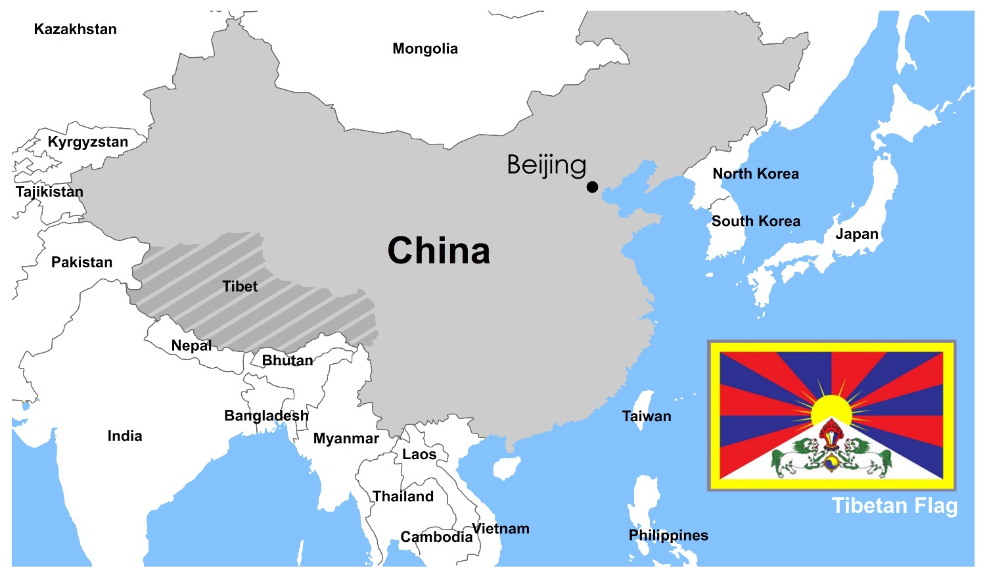

Following attacks by China, the Dalai Lama sought to lead his people by holding many peace talks with the Chinese government. Tibet tried to oppose China but the result was to defeat Tibet and oppress the people.

The Dalai Lama was forced to become a refugee and left Tibet in 1959. He and over 100,000 other Tibetan refugees now live across the border in Dharamsala in Northern India, Nepal and Bhutan. The Dalai Lama has since reminded the world of his country's precarious situation and sought to protect the rights of the Tibetan people. He travelled the world as an ambassador for

his country.

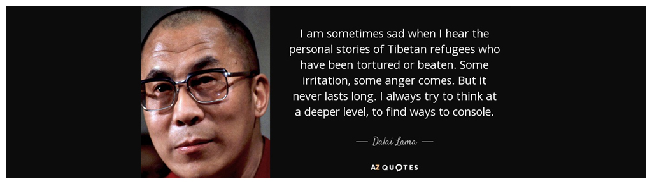

In 1989, he won the Nobel Peace Prize for his non-violent effort for the freedom and rights of the Tibetan people. Although he and others of the Tibetan people had to live as refugees, he still maintained his faith over peaceful efforts for the people of his country. He travelled to 67 countries, spoke to countless leaders and was partly responsible for writing over a hundred books.

In his writing, he often mentioned the fate of refugees. As a refugee for over half a century he is well placed to understand their situation. One of the key words of the Dalai Lama throughout his work is compassion - a word very relevant to the fate of refugees across the world.

One of his most famous sayings is' **Be kind whenever possible. It's always possible '.**

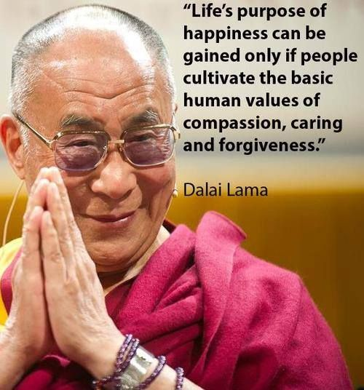

About refugees he said, **'Looking into the face of all refugees, especially the children and girls, we can feel their suffering'**. He has said that the welcome from some European countries to refugees from the Middle East has been excellent. Seeing so many reaching some European countries, he added, **'The ultimate goal is for them to return home to rebuild their country'**. He further said, **'It is impossible for everyone to come to Europe, impossible'**. He highlighted the need to resolve the problems at home through peaceful means. **'Therefore, accepting some thousands of refugees is excellent, but there must be long-term solutions, bringing true peace and development, mainly through education, to these countries'.**

The Dalai Lama has an official web site namely <http://www.dalailama.com/> which is very informative.