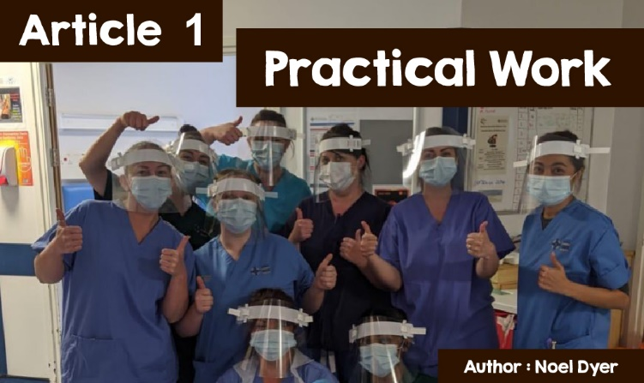

**The Impact of Covid-19 in Wales.**

**Practical Work**

All religions point to the need to help others - especially in times of crisis. The current crisis caused by the coronavirus pandemic has affected us in Wales and every other country in the world. All the scriptures point to the need to respond practically in such a situation. Here are some examples,

*'Do not deny a favour to the one who is entitled to it if you can do it'* (The Jewish Torah).

*'Don't forget to do good and share with others; for it is with such sacrifices that God is pleased'* (The Christian Bible).

*'Be prepared to treat your parents and family with kindness, as will the orphans and those in need; pray regularly and practice charity regularly* '(Quran slam).

*'Give to others, even if you have little'* (Buddha).

Indeed, one of the hallmarks of the current pandemic is the way in which it has brought out the best in many of our communities.

A major concern at the start of the pandemic in March and April 2020 was the lack of PPE equipment needed by all those who came into contact with victims of the illness. These were most needed by care workers mainly, but also many other workers. To make things more difficult, people in the same situation around the world needed them.

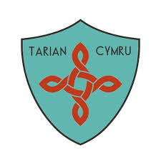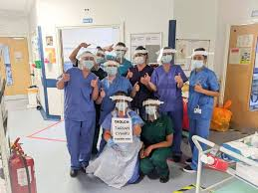

©Tarian Cymru

One person who responded to this was Carl Morris, a 38 year old from Cardiff. He and others set up Tarian Cymru. That group has successfully raised over £90,000 online, providing over 200,000 personal protection items to frontline NHS employees. Carl Morris was inspired to act by his Christian faith. He said, "It's part of my life ... I'm trying to understand something new every day in terms of life, other people, the world, love, and justice". Carl Morris's background is interesting as he was born in Slough in the south east of England, with his father hailing from the Cynon Valley and his mother's family from Malaysia. After moving to Cardiff, he learned Welsh and became a member of Ebenezer Chapel there.

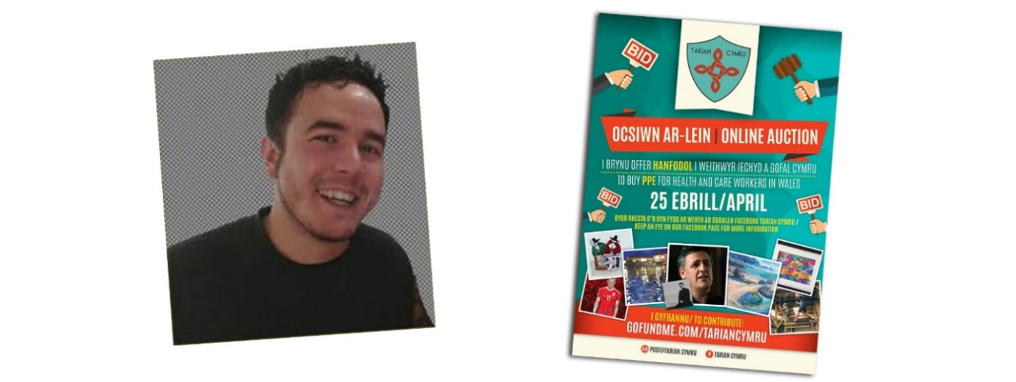

©Tarian Cymru

As well as receiving donations on the web, fundraising has been successful in many ways. One example was an online auction selling a variety of items, including a rugby ball signed by Shane Williams and an original drawing of the cyclist and Tour De France winner, Geraint Thomas. A number of Welsh singers released songs and donated any profits to the charity including Carwyn Ellis, The Gentle Good and Elin Fflur with her timely song, Enfys.

One location that took advantage of this was Antur Waunfawr, near Caernarfon, which lacked safety equipment. Their words show how grateful they were for the help they received, *"We found it very difficult to find sufficient supplies of PPE for our support workers and we heard that Tarian Cymru could help with our appeal. We completed an online questionnaire ... and, in a nutshell, Tarian Cymru found visors and masks ... We are so grateful for their support.”*

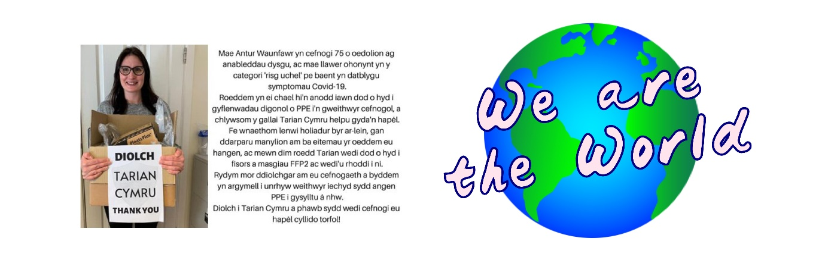

©Tarian Cymru

The Tarian Cymru appeal and personal protective equipment ceased as authorities provided more effectively. On the other hand, there is no end to the worldwide threat of Covid-19. *Tarian Cymru* said, "*We are all also aware that coronavirus is a serious health threat to our neighbours away from home. We believe, as Tarian Cymru,* *that we should respond to the threat facing these communities around the world.”* The result was the launch of Tarian Cymru: We Are the World. The next step is, therefore, to support international humanitarian work that tackles the coronavirus in some of the world's poorest countries. The international work was started with a Rohingya refugee camp that left Myanmar and fled to Bangladesh. There, there is a shortage of clean water, food, and healthcare. There, they will support the work of Christian Aid and its partners who already work there to try to stop the spread of the virus.

**"This lockdown period has opened brand new doors".**

These are the words of the Reverend Nia Wyn Morris, vicar of Newtown, Powys, who feels that she does not wish to go back to the same system that existed before lockdown. The services ceased in March but the church has diversified very effectively. Following willing cooperation with a number of agencies and voluntary organisations, the church is part of a practical plan that provides food and needs for many of the townspeople. According to Nia Wyn Morris, "*As a rector I have had new relationships with other agencies, volunteers, individuals and with the town and every Sunday, together, we provide lunch for over 70 people".* The new situation in March made the people of the area realise the need as most of these people have not had a proper Sunday lunch for a long time. Food costs, of course, but there are all sorts of groups and individuals who are willing to contribute, so that is no problem at all!

 *Jack Williams in his 90's receiving his Sunday Roast dinner.*

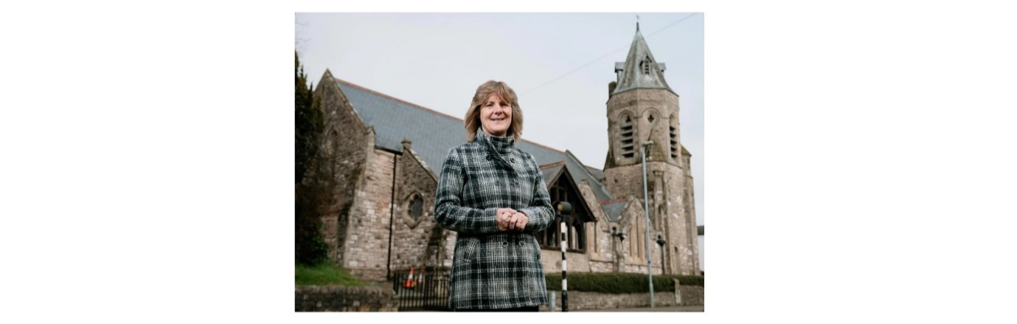

*Canon Nia at All Saints church in Newtown.*

The current situation raises many questions about what will happen when things are back to normal. Will the provision of meals and practical assistance end after lockdown ends? No, is Nia Wyn Morris's response. She said, "*Are we going to stop the lunch provision scheme in order to have an hour’s Sunday service - it's important that the people we have engaged with in the lockdown period continue to enjoy our friendship ... We have identified people's need in this time and we must continue to meet that need somehow - under no circumstances must we go back to normal.”* Certainly, these comments raise some very interesting questions about the role of the church today.

Just over a year ago, Rev Sara Roberts, leader of Bro Madryn churches on the Llyn Peninsula, set up a group in Nefyn to help bereaved people. The intention was to have a monthly event for those who are struggling to deal with the loss of a relative or loved one. Called *Loss Cafe* Sara Roberts said, "*I hear more and more in my job that sadness and bereavement are going on behind people's doors and no-one discusses it in public. What I'm trying to find is a place for people to discuss with each other - a place for people to share their experiences and fears*".

Of course, the face-to-face meeting over a cup of tea ended with the lockdown but a variety of work in the community still continued. People now have to be contacted over the phone and the web, sent newsletters and a CD of services (and web-based services have to be maintained). The Covid-19 food bank was set up with the help of a local councillor to provide food for the truly needy. Occasionally, the Book Opening Team would go into Ysgol Gynradd Nefyn to hold a service but now, they had to do so on the Ysgol Gynradd Nefyn Facebook page. Sara Roberts says,

"Loving God and loving our fellow man is a vocation and a holy order. *A call to protect our weak and vulnerable members is central to our understanding of God and our Christian life.”*



©Welsh Presbyterian Church

**Faith, Hope and Charity....**

**But the greatest of these is**

**Charity**

The current pandemic is affecting all communities. According to the Cardiff Hindu Cultural Society (HCA Wales), *"This is an exceptional time and our priority is to ensure the health and safety of others."* Consequently, a group of volunteers was set up to support the frail and elderly in the community. They struggle to distribute food to the homes of those who can't go out because they are isolated. Many of the volunteers have family and work demands and, so, make a special effort by leaving food at the doors of the person who has contacted via phone to ask for help.

